UI Development task-Kushagra Bhatt

Simple Calculator

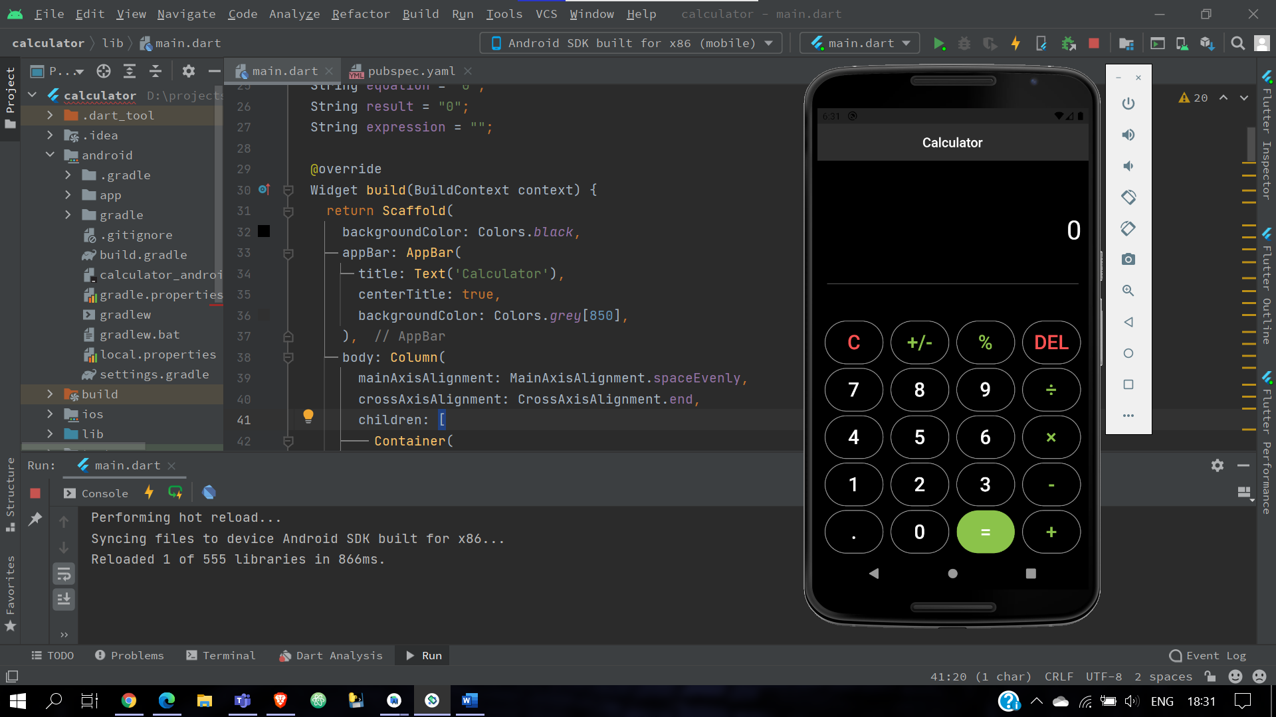

Widgets and layouts

**Containers:** A convenience widget that combines common painting, positioning, and sizing widgets.

**Row and Column:** Row and Column are classes that contain and lay out widgets. Widgets inside of a Row or Column are called children, and Row and Column are referred to as parents. Row lays out its widgets horizontally, and Column lays out its widgets vertically.

**Listview:**  To create a list that scrolls horizontally rather than vertically. The [ListView](https://api.flutter.dev/flutter/widgets/ListView-class.html) widget supports horizontal lists.

**Image:**A widget that displays a image

**Card:** A material design card: a panel with slightly rounded corners and an elevation shadow.

A card is a sheet of [Material](https://api.flutter.dev/flutter/material/Material-class.html) used to represent some related information, for example an album, a geographical location, a meal, contact details, etc.

**Text:** The [Text](https://api.flutter.dev/flutter/widgets/Text-class.html) widget displays a string of text with single style. The string might break across multiple lines or might all be displayed on the same line depending on the layout constraints.

**Center: Center widget** comes built-in with flutter, it aligns its child **widget** to the **center** of the available space on the screen.

**safeArea:** SafeArea is a **widget that inserts its child by sufficient padding to avoid intrusions by the operating system**.

**Stateful vs Stateless widget**

**Stateful widget**

A stateful widget is a widget that describes part of the user interface by building a constellation of other widgets that describe the user interface more concretely. Stateful widgets are useful when the part of the user interface you are describing can change dynamically,

**Stateless widget**

A stateless widget is a widget that describes part of the user interface by building a constellation of other widgets that describe the user interface more concretely. Stateless widget are useful when the part of the user interface you are describing does not depend on anything other than the configuration information in the object itself and the [BuildContext](https://api.flutter.dev/flutter/widgets/BuildContext-class.html) in which the widget is inflated.

**SetState()**

Calling [setState](https://api.flutter.dev/flutter/widgets/State/setState.html) notifies the framework that the internal state of this object has changed in a way that might impact the user interface in this subtree, which causes the framework to schedule a [build](https://api.flutter.dev/flutter/widgets/State/build.html) for this [State](https://api.flutter.dev/flutter/widgets/State-class.html) object.

Generally it is recommended that the setState method only be used to wrap the actual changes to the state, not any computation that might be associated with the change. For example, here a value used by the [build](https://api.flutter.dev/flutter/widgets/State/build.html) function is incremented, and then the change is written to disk, but only the increment is wrapped in the setState: